**Top-down design for Sprint 1**

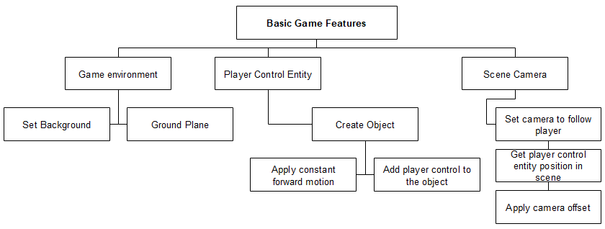

**Top-down design for Sprint 2**

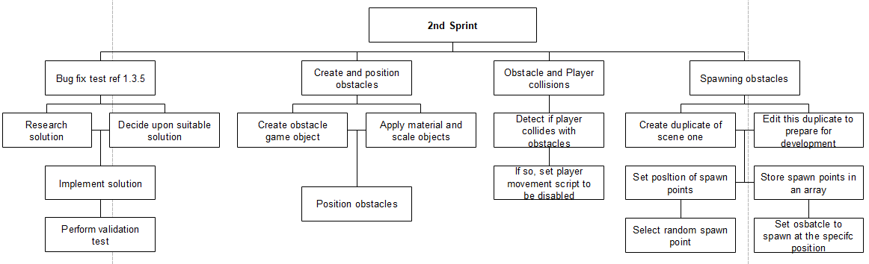

**Top-down design for Sprint 3**

